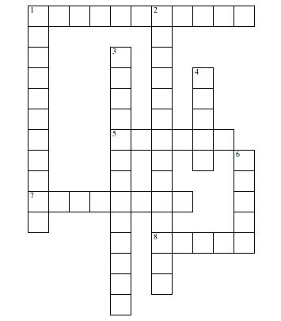

**Photosynthesis**

Complete the crossword puzzle using what you know about the subject. Refer to the word bank if you need help.

**Down**

**Across**

1. Part of a plant cell gathers light energy

5. Waste product of photosynthesis

1. Photosynthesis uses this form of energy to drive the process
2. Compound produced by photosynthesis

1. Part of a plant cell that contains chlorophyll

2. Name of the entire process in which a plant producesits own food

3. One of the two compounds converted during photosynthesis; two words

4. Chlorophyll gives plant life this color

6. Other compound converted during photosynthesis; one word

**Word Bank**

oxygen

carbon dioxide

sugar

green

water

sunlight

chloroplast

chlorophyll

photosynthesis